# **Introduction for Stock Market Analysis**

* Stock analysis involves comparing a company's current financial statement to its financial statements in previous years to give an investor a sense of whether the company is growing, stable, or deteriorating.
* Stock market performance analysis can serve as a basis for investment decisions and help investors make informed decisions about buying or selling stocks. Let us say you work as a data science expert in a company that provides services based on investment decisions. As a data science expert, you can help your company by analyzing the historical performance of various companies, identifying potential opportunities and risks in the stock market, and adjusting your clients' investment strategies accordingly.
* As a data science expert, you can go through a structured process of analyzing stock market performance, which includes collecting historical stock price data of various companies from trusted sources such as Yahoo Finance, visualizing the data using various charts, calculating movements, averages, and volatility for each company, and performing correlation analysis to analyze the relationships between different stock prices
* The stock market is a dynamic and complex system that plays a vital role in the global economy. It provides individuals and businesses with opportunities to invest, raise capital, and participate in economic growth. Stock market analysis is a crucial aspect of understanding and navigating this financial landscape. It involves examining historical data, market trends, and various indicators to make informed decisions about buying, selling, or holding stocks.
* In this mini project, we will delve into the realm of stock market analysis and explore key concepts, tools, and techniques used by investors and traders to evaluate stocks and identify potential investment opportunities. We will explore fundamental analysis, which focuses on examining a company's financial health, earnings, and competitive position, as well as technical analysis, which involves studying price patterns, trends, and market psychology.

# **Importing modules**

import pandas as pd

import numpy as np

import matplotlib.pyplot as plt

from sklearn.model_selection import train_test_split

from sklearn.linear_model import LinearRegression

from sklearn.metrics import mean_squared_error,mean_absolute_error

from sklearn.ensemble import RandomForestRegressorv

# **Reading the Dataset**

df=pd.read_csv("D:\\miniproject\\stocks.csv")

df

**output:**

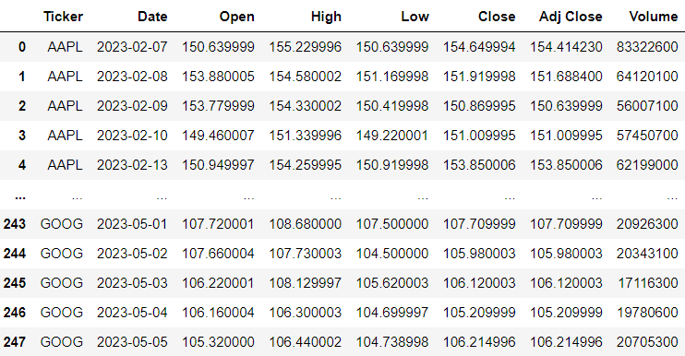

# **Dropping the unwanted column**

df.drop(['Ticker','Adj Close'],axis=1,inplace=True)

df

**output:**

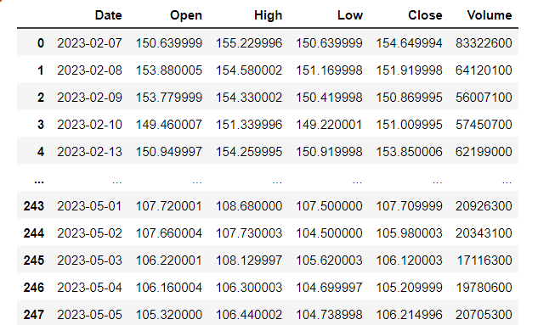

# **Data checks to perform**

**#To check first five columns**

df.head()

**#To check last five columns**

df.tail()

**#checking missing values**

df.isnull().sum()**or**df.isnull().any()

**output:**

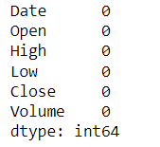**or** 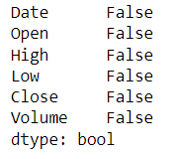

**#checking information about dataset**

df.info()

**output:**

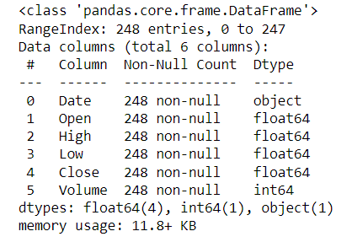

**#check statistics of dataset**

df.describe()

**output:**

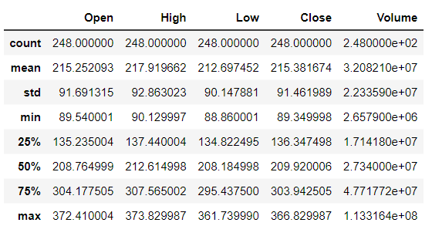

print('length of dataset:',len(df))

print('shape of the dataset',df.shape)

print("Number of columns in the dataset:",df.columns)

**output:**

lenghth of dataset: 248

shape of the dataset (248, 6)

Number of columns in the dataset:Index(['Date', 'Open', 'High', 'Low', 'Close', 'Volume']

# **Explorartory data analysis**

**# plotting Line graph for opening the stock market**

df['Open'].plot(figsize=(16,6))

plt.title('Linechart')

plt.xlabel('Open')

plt.ylabel('frequency')

plt.show()

**output:**

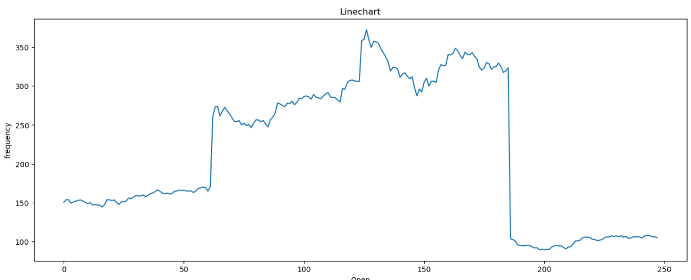

**Summary:_____________________________________________________________________________________________________________________________________________________________________________________________________________________________________________**

**__________________________________________________________________________________**

# **Data preprocessing**

**#splitting the date column into year,month,day**

x=df

x['year']=pd.DatetimeIndex(x['Date']).year

x['month']=pd.DatetimeIndex(x['Date']).month

x['day']=pd.DatetimeIndex(x['Date']).day

x

**output:**

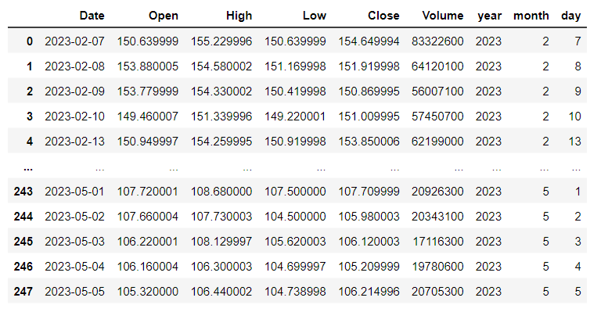

# **Training the model for MultipleLinearRegression**

**#splitting the dataset**

x=df.drop(['Close','Date'],axis=1)

y=df['Close']

x_train,x_test,y_train,y_test=train_test_split(x,y,random_state=0)

print('xtrain:',x_train.shape)

print('xtest:',x_test.shape)

print('ytain:',y_train.shape)

print('ytest:',y_test.shape)

**output:**

xtrain: (186, 7)

xtest: (62, 7)

ytain: (186,)

ytest: (62,)

**#model training**

regressor=LinearRegression()

regressor.fit(x_train,y_train)

**output:**

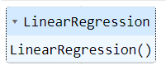

**#To check intercept and co-efficient**

print('intercept:',regressor.intercept_)

print('Co-efficient:',regressor.coef_)

**output:**

intercept: -0.6115052912800536

Co-efficient: [-5.45434461e-01 7.34498290e-01 8.12746520e-01 4.09319930e-096.34908792e-16 1.03687704e-01 1.15818167e-03]

**#Predictions**

y_pred=regressor.predict(x_test)

y_pred

**output:**

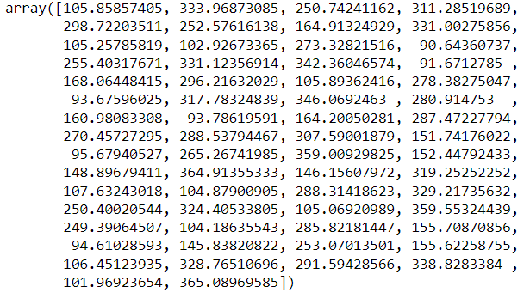

**#Evaluating the model**

train_accuracy=regressor.score(x_train,y_train)

print('train_accuracy(R_Squared):',train_accuracy)

test_accuracy=regressor.score(x_test,y_test)

print('test_accuracy(R_Squared):',test_accuracy)

print('Mean Absolute Error:',metrics.mean_absolute_error(y_test,y_pred))

print('Mean Squared Error:',metrics.mean_squared_error(y_test,y_pred))

print('Root Mean Squared Error:',math.sqrt(metrics.mean_squared_error(y_test,y_pred)))

**output:**

train_accuracy(R_Squared): 0.9996274457101879

test_accuracy(R_Squared): 0.9996351890659423

Mean Absolute Error: 1.3038307748950013

Mean Squared Error: 3.3155240230458447

Root Mean Squared Error: 1.8208580458250567

**#To check actual price ,predictedprice and difffrence**

dfr=pd.DataFrame({'Actual Price':y_test,'Predicted Pric:y_pred,'Diffrence':y_test-y_pred})

dfr

**output:**

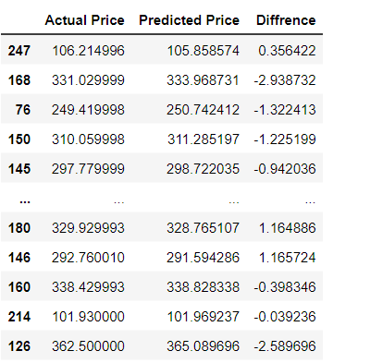

**#Plotting the bar graph to check difference between actual price and predicted price**

graph=dfr.head(20)

graph.plot(kind='bar')

plt.title('BarGraph')

plt.xlabel('Actual&prediceted price')

plt.ylabel('frequency')

plt.show()

**output:**

**summary:________________________________________________________________________________________________________________________________________________________________________________________________________________________________________________________________________________________________________________________________**

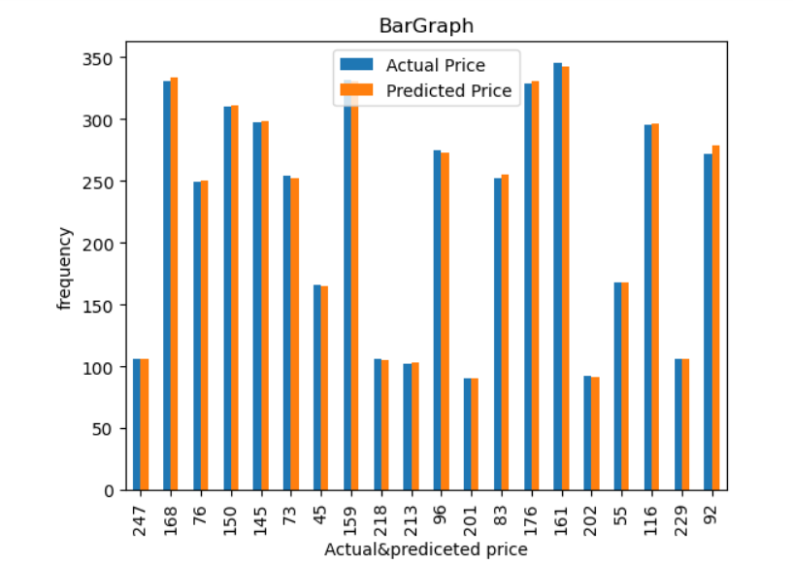

# **Training the model for RandomForestRegressor**

**#model training**

from sklearn.ensemble import RandomForestRegressor

regressor = RandomForestRegressor(n_estimators=100,random_state=0)

regressor.fit(x_train,y_train)

**output:**

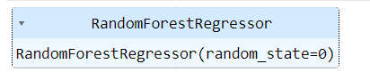

**#Evaluating the model**

train_accuracy=regressor.score(x_train,y_train)

print('train_accuracy(R_Squared):',train_accuracy)

test_accuracy=regressor.score(x_test,y_test)

print('test_accuracy(R_squared):',test_accuracy)

**output:**

train_accuracy(R_Squared): 0.9998571271849735

test_accuracy(R_squared): 0.9987098858585105

**#Comparision between Linear and RandomForestRegression using barplot**

linear_regression_accuracy =0.9995657233927607

random_forest_accuracy =0.9987098858585105

accuracy_scores = [linear_regression_accuracy, random_forest_accuracy]

model_names = ['Linear Regression', 'Random Forest Regression']

plt.bar(model_names, accuracy_scores)

plt.xlabel('Regression Models')

plt.ylabel('Test Accuracy')

plt.title('Comparison of Test Accuracy: Linear Regression vs Random Forest Regression')

plt.show()

**output:**

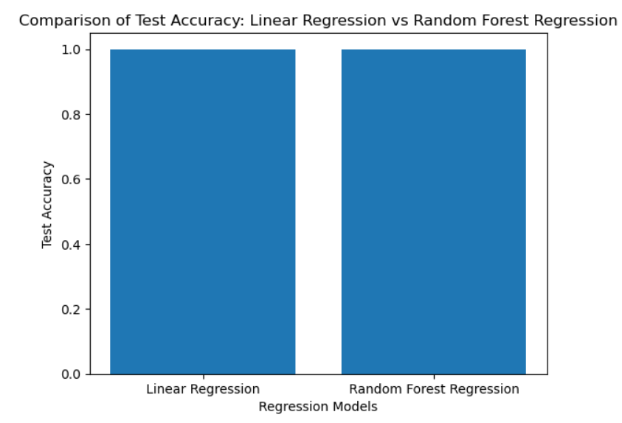

**Summary:**